**Internships Available**

**Interviews will be held:**

**Friday and Saturday, January 14 and 15**

**In the Career Services Conference Room**

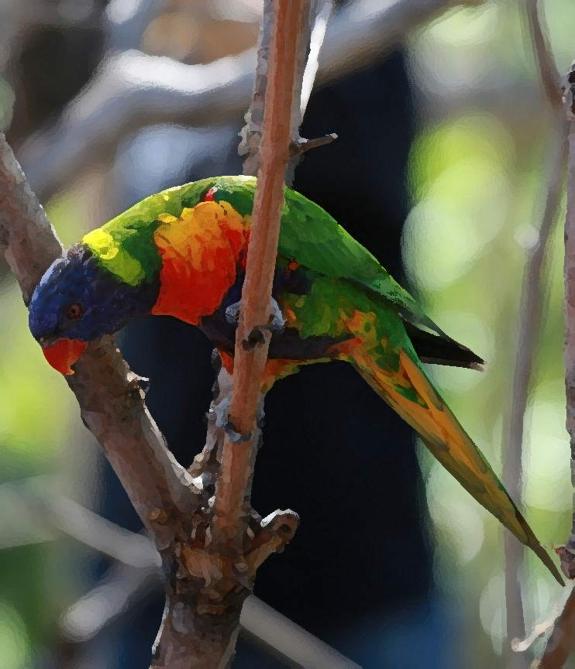This summer, Sturgeon Point Productions will be filming a short documentary in Costa Rica about its native birds and has positions available for two interns. The filming will begin the first week of July and will last approximately two weeks. Payment will be by Day Rate of $100 per day. Transportation, food, and lodging will be provided.

The First Assistant Director will work with the second film crew, which will be filming background video. The Assistant Script Supervisor will work with the Script Supervisor and will be responsible for coordinating communication between the two camera crews.

You must have a valid U.S. passport; no inoculations are necessary. Details are available on the company website.

**To set up an interview, apply online at:**

**www.SturgeonPointProductions.com**